Peace Building Development Consult (PBDC),
Global Affairs & Security Newsletter

DIPLOMACY, INTERCONTINENTAL RELATIONSHIPS, AND THE PURSUIT OF PEACE

Introduction
In an increasingly interconnected world, diplomacy remains a central instrument for managing conflict, strengthening alliances, and sustaining global peace. Contemporary geopolitical tensions involving the United States, Israel, and Iran illustrate how strategic rivalries influence international security dynamics. Their complex relationship—shaped by ideological differences, military competition, and regional security concerns—offers important insights into the role of diplomacy in preventing escalation and promoting stability.

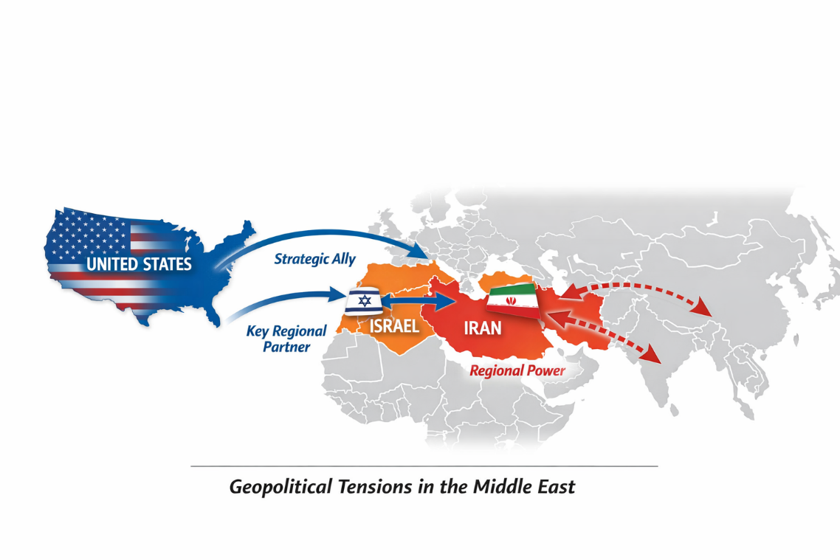

Historical Context
The roots of tension between the United States, Israel, and Iran date back several decades. Before the 1979 Iranian Revolution, Iran maintained relatively cooperative relations with the United States and indirect strategic alignment with Israel. The revolution, however, transformed Iran into an Islamic Republic with a strongly anti-Western and anti-Israeli orientation.
Several developments intensified the geopolitical rivalry, including the breakdown of U.S.–Iran diplomatic relations, disputes over Iran’s nuclear programme, and Iran’s expanding influence across the Middle East. Over time, these dynamics have created a complex regional security environment with significant global implications.

Diplomacy and Strategic Alliances
Diplomacy remains the primary non-military mechanism for managing tensions among these actors. The United States maintains a strong strategic partnership with Israel, characterised by defence cooperation, intelligence collaboration, and technological support. This alliance plays a major role in shaping regional security strategies.
At the same time, Iran has developed relationships with several regional actors and political movements, allowing it to project influence and counterbalance opposing alliances. These networks of partnerships contribute to a broader geopolitical competition that extends beyond the Middle East.

Global Security Implications
Although centred in the Middle East, the rivalry carries wider international consequences. Concerns over nuclear proliferation, the risk of military escalation, and the potential disruption of global energy markets highlight the importance of diplomatic engagement. Conflicts in strategically important regions can quickly affect international trade, economic stability, and broader global security frameworks.

Peacebuilding and Diplomatic Pathways
Despite persistent tensions, diplomacy continues to offer viable pathways for conflict management. Sustained dialogue, confidence-building measures, transparency agreements, and international mediation remain essential tools for preventing escalation. Multilateral negotiations and international institutions also play a crucial role in encouraging cooperation and maintaining accountability.

Looking Ahead
The evolving dynamics between the United States, Israel, and Iran demonstrate the enduring importance of diplomacy in global affairs. In a world characterised by competing interests and shifting alliances, sustained diplomatic engagement and international cooperation remain the most effective instruments for reducing tensions and promoting lasting peace.
Peace Building Development Consult (PBDC)
Global Affairs & Security Newsletter
Stay informed. Stay engaged. Support diplomacy and peacebuilding worldwide.

